AI-Based Real-Time Flood Monitoring

Vandan Gowda
Department of Computer Science & Engineering, Presidency University,
Bengaluru, India
vandangowda691@gmail.com

Anusha H G
Department of Computer Science & Engineering, Presidency University,
Bengaluru, India
anushahg2003@gmail.com

Mohammadi Akheela Khanum
Department of Computer Science & Engineering, Presidency University,
Bengaluru, India
akheela.khanum@presidencyuniversity.in
Vaishnavi Salunke
Department of Computer Science & Engineering, Presidency University,
Bengaluru, India
vaishnavisalunke6362@gmail.com

Abstract: Flood disasters or flood catastrophes are still one of the main threats to human life and property due to their enormous impact. The main condition for riskless and successful flood mitigation is accurate and real-time monitoring and forecasting. This work presents a new AI-based flood monitoring system, which combines state-of-the-art machine learning algorithms with data from the IoT sensors. Environmental data such as water level, rainfall and humidity, which are collected from the various sensors, are then passed to a trained Random Forest classifier for prediction of flooding in real time. The fast response is supported by the system's automatic alert mechanisms and the user-friendly dashboard. The method is a boon to disaster management as it offers predictions that are reliable, scalable, and extremely precise, which has been confirmed by both synthetic and real data sets.
Keywords: Predictive analytics, environmental monitoring, cloud computing, Random Forest, sensor networks, early warning systems, water level sensing, Internet of Things (IoT), and disaster management.

Introduction
Floods are considered the most severe and frequent natural disasters worldwide and they cause extensive damage to agriculture, infrastructure, and human settlements, in the order of billions of dollars annually [1], [2]. There has been a recent increase in floods due to global warming, rapid urbanization, and changing land use patterns, thus making the use of traditional early warning and mitigation techniques less effective. In order to minimize losses and ensure timely interventions, real-time prediction and monitoring have become essential [3], [4].

Standard flood forecasting generally relies on periodically refreshed data and stationary hydrological models [5], [6], which might not consider the arrival of extreme weather events or the dynamic nature of river basins. The emergence of Internet of Things (IoT) sensor networks, artificial intelligence (AI), and machine learning (ML) have enabled to merge the environmental data from different sources for better predicting and warning [7, 9]. These setups make it possible to recognize and evaluate the flood risk more accurately and effectively by applying methods based on sensors and data.
AI-based solutions, especially ensembles of machine learning models and deep neural networks, have been more effective than classical techniques in flood detection and warning [2], [10]. IoT alert systems facilitate data capture from sensors to be the decision makers and the community [11], [13] without delay. The proposed study analyses a real-time flood monitoring system that incorporates AI and IoT technologies, aiming to increase the efficiency and reliability of flood risk evaluation and countermeasures.

Literature Review
Initial investigations into flood monitoring made use of geographic information systems, hydrological models, and online tools to represent river dynamics and provide the information to the relevant agencies in near real time [5], [6]. These systems allowed for spatial mapping of the floods and decision-making with data; however, they very often did not interface with continuous, real-time measurement sources. To meet the increasing demand for real-time, high-resolution data, IoT-enabled sensor networks were deployed in flood-prone areas [9], [14]. Such networks could monitor key environmental parameters, such as water level, precipitation, flow rate, and humidity, usually utilizing wireless data transmission and low operation costs [11], [15]. The scalability and flexibility demonstrated in the systems have been responsible for an upsurge of research projects devoted to improving the reliability and coverage of operations.

With the simultaneous progress of cloud computing and machine learning, several researchers have already replaced the old-fashioned risk assessment and alerting techniques based on static thresholds with AI algorithms [7], [10]. Among the various methods, Random Forests, support vector machines, and deep neural networks—including CNNs and LSTM variants—are capable of processing huge amounts of real-time sensor data and finding out complicated causes and effects of floods over time and space [1], [2]. Moreover, the combination and ensemble models have shown to be more accurate and stronger than the single models in complex or data-scarce situations. On the other hand, the computer vision techniques are being developed for flood image analysis and inundation mapping, which in turn is increasing the level of situation awareness [16].

Despite the clear advances, the literature still points out to major challenges that are still there. The integration of data from varied sensors, the assurance of safety for the cloud-based monitoring services, the handling of noisy or missing readings, and the tuning of models according to different geographical areas are still not resolved research challenges [17], [6]. There is already a high demand for public-facing dashboards, the automated distribution of alerts through multiple channels, and quick adaptation to changing sensor infrastructure [19], [13]. The present research adds to the earlier ones by presenting the holistic AI-enabled real-time flood monitoring system that consists of IoT detection, sophisticated machine learning, and emergency communication tools for easy application in disaster management contexts.

System Architecture
It is based on a multi-tier strategy in order to optimize end-to-end flood prediction by using sensors, advanced analytics, and multi-channel alerts.Fig.1 summarizes the basic elements and functional workflow of this architecture.

- Hardware Layer:
Sensor deployment: The Γ−monitoring systems utilize a diverse set of environmental sensors including water level sensor, rainfall sensor and temperature sensor [14], [17]. Situated in the riverbanks, reservoirs and flood-prone areas of towns and cities, as well. Data are recorded in real-time and at a high frequency. All sensors have standard digital interfaces, and all are calibrated locally to maintain their accuracy under adverse weather conditions.
Edge Preprocessing: Data pre-filtration at the microcontroller gateways (commonly on Arduino, ESP32 or Raspberry Pi) carry out certain checks (e.g., in range validation and noise filtering) to securely transmit one or more data to the cloud using Wi-Fi / LoRa / GSM modems. This in which lowers the amount of bandwidth used, and consquently lower latency [23].
- Cloud/Backend Layer:
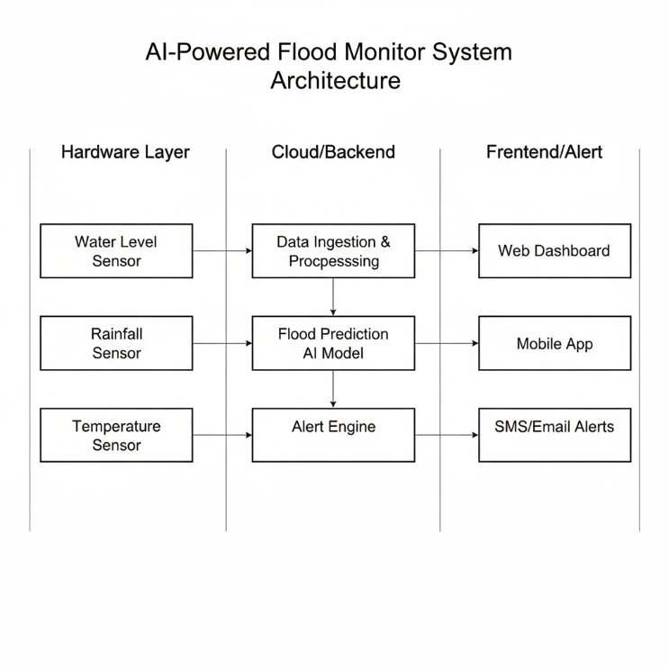
Data Ingestion & Processing: The data collected from the sensors are combined at edge on a scalable cloud platform. Streaming and data ingestion frameworks such as Apache Kafka, MQTT brokers enable real-time ingestion of data. ETL processes perform relentless cleaning, interpolation of missing entries and outlier removal as well as transformation operations, such as unit conversions and normalization of measurements [10], [20]. The backend will be a modular, RESTful API utilizing 3rd party government databases and external weather feeds.
Flood Prediction AI Model: As a machine-learning backbone, it utilizes the Random Forest or Gradient Boosted Trees classifiers trained from multi-year historical sensor information and meteorological inputs [2], [24]. The model pulls in the relevant features — rate-of-rise of water levels, intensity of rainfall, spikes in temperature — and combines those with external variables (soil moisture, discharge from an upstream dam, etc.) to estimate the probability that a flood would occur in the next few hours or days.
Alert Engine: The model output is further processed by a business rule layer. Rules can include severity thresholds, spatial propagation analysis (through the use of GIS overlays) [1], and user-defined risk aversion levels. Upon flood risk detection, the engine action alerted (in the wrapper) with downstream UI context to secure webhook and cloud messaging endpoints.
- Frontend/Alert Layer:
Web Dashboard: Administrators are provided with real-time visualization of data on dashboards equipped with rich features to show the real time river level, maps for rainfall, system health, upcoming risks through interactive filtering and GIS overlays [5], [20].
Mobile Application: A mobile app introduces a lightweight solution which empowers field technicians to be notified and read sensors manually, and also checking the status of the system while maintaining functionality even in minimal connectivity conditions [3].
SMS/Email Alerts: Automated alert notifications with risk assessment, and response incentives are sent via SMS/Email by utilizing cloud gateway APIs (Twilio, AWS SES), which is also adjustable according to geofenced subscriber list and jurisdictional ladder [11], [19].
Scalability & Security: All communication channels are secured (TLS) with multi-factor auth for admin operations along with local failover capabilities in protecting against node-level failures and disaster recovery scenarios.
- System Feedback and Adaptation:
The architecture enables live installation of new sensors (plug-and-play onboarding), active model retraining with newly arriving data, user-specific parameter configuration for tunable deployments, and reciprocal feedback loop from end-users to backend analytics systems (through alert confirmations and incident reports) [17].

- Deployment and Maintenance:
Automated cloud based monitoring solutions identify device failures, abnormal behaviour and security events and notify system engineers to take immediate action. Planned firmware updates and also API reviews guarantee longevity and future scalability [17].
Fig.1. AI-powered real-time flood monitoring platform's system architecture.

Proposed Methodology
The planned approach of the AI-based real time flood monitoring system is designed with a systematic procedure which consists of five major steps, as shown in Fig. 2. There are critical roles for each of these in turning raw sensor data into actionable flood risk assessments and alerts.

Data Acquisition (IoT Sensors)

The first phase is the streaming of real-time environmental information using an IoT sensor network in flood prone areas, gathering data continually [7], [15]. The sensors acquire instantaneous readings of water level, rain intensity, temperature, humidity and flow rate. The information’s would be time stamped and wireless transmitted (MQTT/ LoRa or GSM) First, to maintain a stable communication link in a remote area.

Edge & Cloud Preprocessing

The raw sensor data is firstly validated and filtered at the edge, being utilized to eliminate noises, identify sensor failure, and conduct range checking [4]. After this, the checked data is sent to the cloud [17], [13] where extensive preprocessing is performed. This includes processing Missing values using an interpolation technique, Outlier Treatment process to make sure there are no violations of basic assumptions involving these two data points, Normalization part of the pre-processing stage since it scales all numeric variables so that they’re within a similar range and lets model converge faster and Performs Feature Engineering to come up with meaningful metrics.

Feature Selection & Model Training
The classifier used to predict flood risk in the system is Random Forest, because of its non-linear relationship robustness [10]. Important attributes considered for the model are water level, intensity of rainfall, rate change in water level, total precipitation volume, humidity and temperature readings [1]. We train the model on historical information and sensor measurements of floods in order to capture patterns of flow that indicate a flood.

Real-Time Prediction Pipeline

After training, the model is deployed in the cloud for online inference [9], [13]. New incoming sensor data streams go through the same preprocessing process with features calculated automatically. The Random Forest model estimates a flood risk score (likelihood for having flood), and the system maps scores against rule-based logic to LOW, MEDIUM, or HIGH categories based on a threshold of probability [4]. Other factors (e.g., current weather warnings) or contextual information (like archival flood pattern at the location) are utilized to enhance prediction [21].
- Alert Generation & User Notification
The trained model is deployed to the cloud for on-line inferences [9]. New sensor data streams from new participants are subjected to the same preprocessing pipeline and features can be derived without external help. The flood risk score (likelihood of flood) scores in terms of a probability expression have been assigned to the model and rule-based logic has been used to classify the levels by considering the threshold level [4]. Other contextual reasons- e.g., weather forecasted for the date and historical flooding patterns at the site- are included to enhance predictions [21]. The system generates Automated alerts if a flood risk is identified that the decision makers and the communities get warning in advance to decrease impact [11], [19].

Feedback & Model Improvement

The system continually feeds back on itself for further calibration and adjustment. Users can affirm or debunk the alerts and add comments to actual flood events, as well as upload field reports via the site or mobile platform. This feedback is recorded, and retraining of the model occurs at regular intervals to decrease false alarms and to adapt to seasonal changes, sensor drift, varying setting conditions, etc. [17], [6]. The system also allows for automatic retraining of the model, which can lead to a gradual increase in prediction accuracy and trustworthiness.

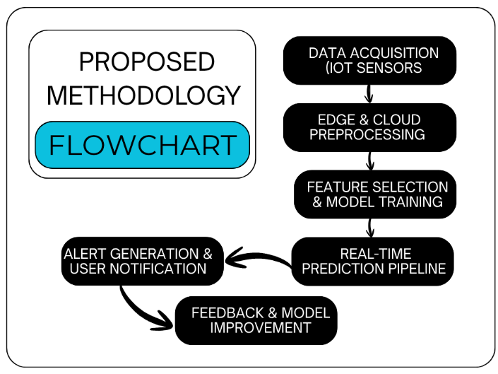
The complete methodology provides a robust, scalable, and flexible flood monitoring solution based on experimental determination of a system using IoT sensing, machine learning, and multi-channel communication for disaster mitigation [7], [9].
Fig. 2. Proposed Methodology Flowchart for AI-based Real-Time Flood Monitoring System.

Simulation Results and Analysis
We developed and tested our real-time AI-based monitoring system for flood through a web application built with Flask on top of OpenWeatherMap API, along with the trained Random Forest classifier [1]. This section provides the simulation results to illustrate how the system functions and to quantify its performance.
- Implementation and Configuration of System

The system was developed on server based on a Python framework. TABLE I presents the summary of all software specifications and components utilized in the implementation. Random Forest was built with 120 decision trees, learning from synthetic data that consists of 3,000 samples described by eight environmental variables.

Component | Specification
Programming Language | Python 3.8+
Web Framework | Flask (Backend server)  HTML/CSS/JavaScript (Frontend)
Machine Learning  Library  Algorithm | Scikit-learn 1.0+  Random Forest Classifier  (n-estimators=120)
Data Processing Libraries | Pandas, NumPy
External Data Source | OpenWeatherMap API  (Real-time weather data)
Sensor Data Simulation | Simulated river sensor readings (Water level,Flow rate)
Communication Protocol | RESTful API (HTTP/HTTPS)  JSON data format
Deployment Environment | Local/Cloud server compatible (localhost:5000)
Model Storage | Joblib serialization (artifacts/model.pkl)
Data Scaling | StandardScaler(artifacts/model.pkl)
Operating System | Cross-platform (Windows)
TABLE I System Software Specifications and Components.

The feature types and the value ranges, which are listed in TABLE II.
Parameters | Value
Dataset Size | 3,000 samples
Training Set | 2,400 samples (80%)
Test Set | 600 (20%)
Number of Features  - Average Temperature  - Maximum Temperature  - Wind Speed  - Cloud Cover  - Total Precipitation  - Average Humidity  - Water Level  - Flow Rate | 8  Continuous (°C)  Continuous (°C)  Continuous (m/s)  Continuous (%)  Continuous (mm)  Continuous (%)  Continuous (m)  Continuous (m^3/s)
Random Forest Parameters  - Number of Trees  - Max Depth  - Random State | 120  Unlimited  42
Classification Labels | Binary (0: No Flood,1: Flood)
Model Accuracy | >90% on test set
Table II Model Training Parameters and Dataset Characteristics.

- Web Dashboard Interface
A web-based user interface to view the flood map in real-time is made available with the system [20]. Fig. 3, a homepage is provided, which has a straightforward user experience and does not inconvenience users with too many buttons to worry about; just provide monitoring city name or coordi- nates. Its dashboard presents functionality of the system such as online risk score computation, weather data uploading and analysis via GIS, interactive witnessing (visualization with map), intelligent pre-alerting [5].
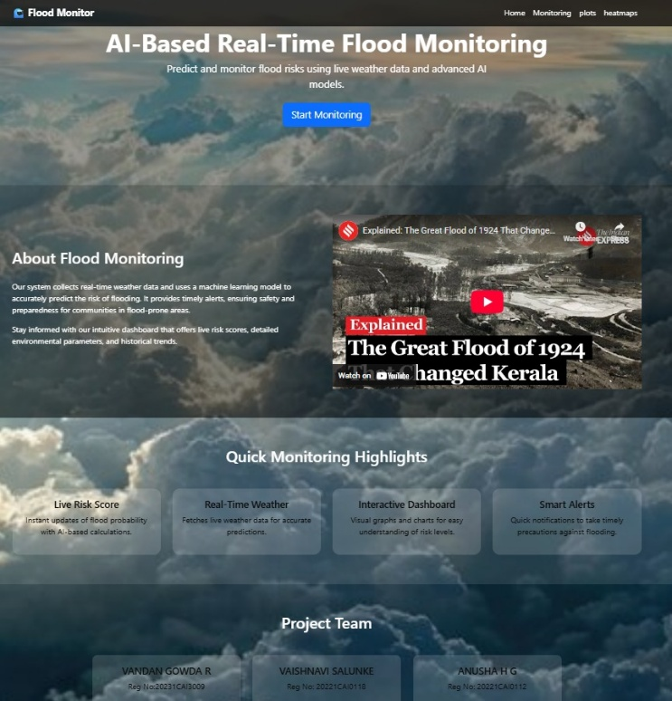
Fig. 3. Web Dashborad Interface for live flood risk monitoring.

- Real-Time Monitoring and Risk Scoring
Fig. 4 shows the real-time monitoring of the system for a mock run on Bangalore city. At the top of the dashboard there is a ‘Flood Risk Monitoring (Live)’ time-series plot showing temporal snapshots of risk scores being monitored overtime [13]. In the present simulation, the system calculated a flood risk category of MEDIUM with a percentage mark of 48.33%, which reflects moderate chances of flooding according to presented meteorologic variables. Risk categories are, for predictions on a LOW (below 40%), MEDIUM (40%-70%) or HIGH (above 70%) which can be easily interpreted by end-users and emergency response personnel [4].

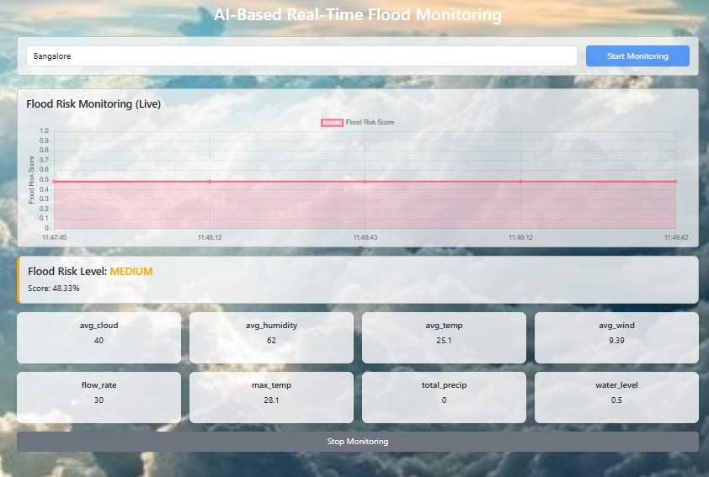
Fig. 4. Home Page System description and Monitoring Interface with highlights.
- Environmental Parameter Display
The dashboard visualizes the current environmental data and simulated sensor values that are fetched from OpenWeatherMap API, in card layout for readability [9], [14]. As shown in Fig. 4, the monitoring session recorded parameter values as: mean cloud cover (40%), mean humidity (62%), mean temperature (25.1 degree Celsius), mean wind speed (9.39m/s), flow rate (30 m3/s), maximum temperature (25.1 degree Celsius), total precipitation (0 mm), and water level- 0.5m. Then the following parameters are used as input features for Random Forest model in flood risk modelling [1],[7].
- Feature importance Analysis
Fig. 5 shows the strength of importance in terms of each environmental factor to the decision determination made by Random Forest model [10]. Water level is the most important predictor (importance score 0.30), followed by total precipitation (0.22) and flow rate (0.18) [1]. This means that the model is indeed capturing those hydrological variables most directly related to the occurrence of floods.
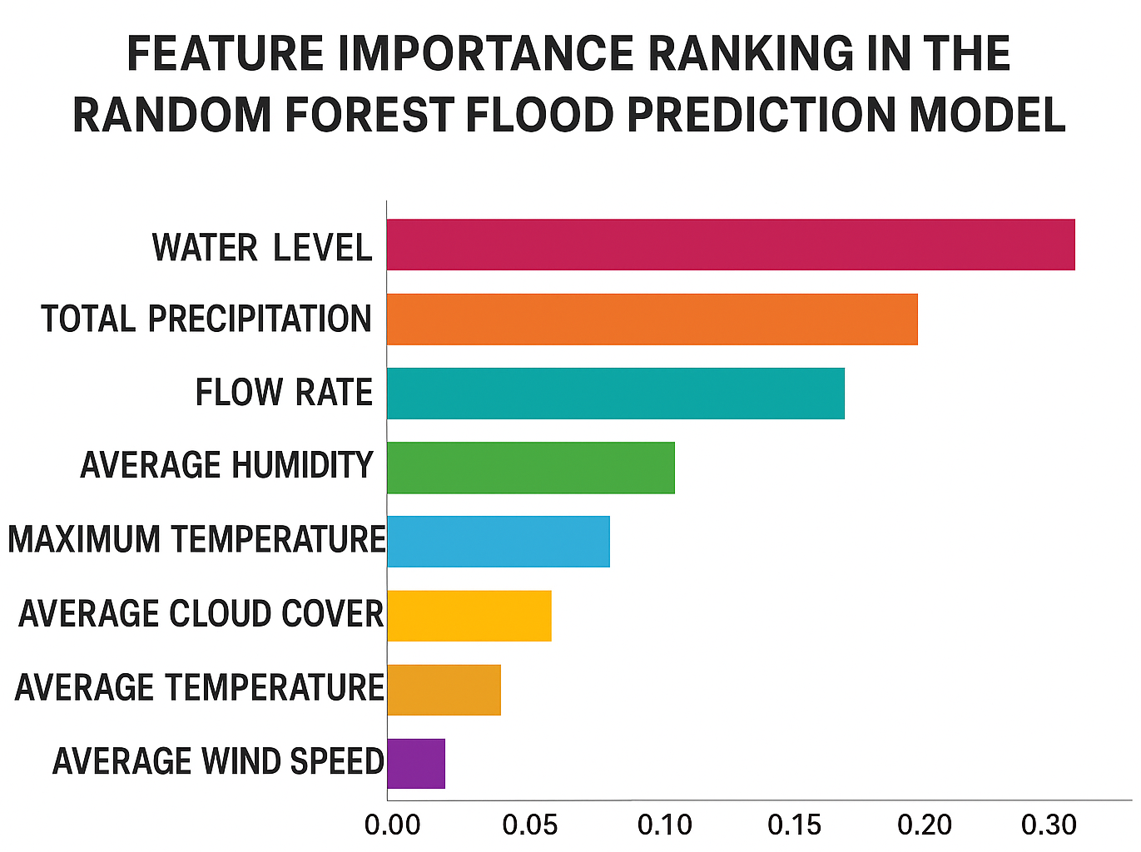
Fig. 5. Importance of features in the Random Forest flood prediction model.

- System Performance and Validation
The simulation tool, adequately, it worked well with the overall response time of less than 3 seconds for the end-to-end process, which includes API invocation and preprocessing, followed by model inferences and visualization [13]. In the time series, continuous flood risk is visualized, allowing users to see how risks have evolved over time and anticipate when flood risks are increasing towards critical limits. The system was successfully tested to combine real-time weather inputs and machine-learning-based prediction to produce an actionable flood risk assessment through a friendly web interface.

Discussion And Future Challenges
The developed AI-based in situ flood monitoring system has successfully combined machine learning with real-time information and offers timely assessments of the risk of flooding thereby overcoming traditional shortcomings like the latency before a flood is observed or spatial expediency loses accuracy [5], [21]). The Random Forest can effectively identify the flood-vulnerable state using multi-parameter environmental conditions [10]. Operational Deployment Challenges Despite the successful implementation, operational deployment is challenging due to data quality (river gauges and sensor reliability) as well as the fact that we currently use simulated river data and external API services, which can be temporarily unavailable [6]. The generalisation of a model can be limited by infrastructure protectioning such as multiple river basins, and the use of synthetic training data restricts the system’s capacity to capture real-world flood complexities including flash floods and urban drainage interactions [10].
Upcoming work needs to focus on applying physical IoT sensor networks for actual high frequency measurements in sensitive river basins [9], [15]. Advanced deep learning diagrams such as LSTM and CNN can be employed to capture spatio-temporal features and consequently yield better predictive performance [2]. The real-time inundation mapping can be improved by satellite images integration [16]. Broadening the distribution of multi-modal alerts via emergency broadcast systems and social media offers better reach to the general public [19], [13]. Ensemble modelling methods that combine multiple algorithms can enhance stability [10]. Successful implementation also fosters collaborative work through which hydrologists, data analysts and decision-makers can work together with local communities in co-designing resilient social-technical systems [23], [24].

Conclusion
This paper proposed an AI-enabled cloud-based real-time flood monitoring system in which the IoT data, Random Forest-based classification, and multi-channel alerts are combined in order to improve the accuracy of flood prediction and disaster management [1], [9]. The Web interface allows disaster management authorities to visualize risk and monitor in real time [20], [13]. Results from the simulations showed that performance was effective, with a sub-3-second response time to alert and correctly categorize risk. Importance analysis correctly identified water level, precipitation, and flow rate as being the most important predictors [1], [10]. Physical IoT sensors need to be deployed in the future, and deep learning architectures should be investigated, and satellite imagery needs to be incorporated and alert systems enhanced with joint efforts [16], [2]. The present investigation provides a basis for intelligent disaster monitoring and environmental risk assessment technology.

References
- M. Nihal, D. Aji, A. Prabhakaran, K. P. Siby, L. S. Anand, and V. K, "AI Based Early Flood Monitoring and Detection," 2024 International Conference on E-mobility, Power Control and Smart Systems (ICEMPS), Thiruvananthapuram, India, pp. 1–5,2024..https://doi.org/10.1109/ICEMPS60684.2024.10559317.
- E. Samikwa, T. Voigt, and J. Eriksson, “Flood prediction using IoT and artificial neural networks with edge computing,” in Proceedings of the 2020 International Conferences on Internet of Things (iThings), IEEE Green Computing and Communications (GreenCom), IEEE Cyber, Physical and Social Computing (CPSCom), IEEE Smart Data (SmartData), and IEEE Congress on Cybermatics (Cybermatics), Rhodes, Greece, 2020, pp. 234–240, Accessed: Nov. 13, 2025.https://doi.org/10.1109/iThings-GreenCom-CPSCom-SmartData-Cybermatics50389.2020.00053.
- A. S. Kale and M. R. Dixit, “Flood monitoring and alerting system,” International Journal of Engineering Research & Technology (IJERT), vol. 9, no. 9, pp. 590–593, Sep. 2020, doi: 10.17577/IJERTV9IS090340.
- H. Nadella, J. Ashish, and R. Brindha, "IoT Based Early Flood Alerting System," International Journal of Innovative Science and Research Technology (IJISRT), vol. 9, no. 4, pp. 2821–2826, Apr. 2024, Accessed: Nov. 13, 2025. https://www.ijisrt.com/assets/upload/files/IJISRT24APR2438.pdf.
- “A Real-Time Hydrological Model for Flood Prediction using GIS and the WWW,” Accessed: Nov. 13, 2025. https://www.researchgate.net/publication/222419337_A_Real-Time_Hydrological_Model_for_Flood_Prediction_using_GIS_and_the_WWW.
- H. L. Cloke and F. Pappenberger, "Ensemble flood forecasting: A review," Journal of Hydrology, vol. 375, no. 3-4, pp. 613–626, Sep. 2009, Accessed: Nov. 13, 2025. https://doi.org/10.1016/j.jhydrol.2009.06.005.
- A. I. Pathan, “An IoT and AI based Flood Monitoring and Rescue System,” International Journal of Engineering Research & Technology (IJERT), vol. 9, no. 09, Sep. 202, Accessed: Nov. 13, 2025.https://doi.org/10.17577/IJERTV9IS090340.
- P. Smith, “An intelligent and adaptable grid-based flood monitoring and warning system,” in Proc. 5th UK e-Science All Hands Meeting, Citeseer, 200, Accessed: Nov. 13, 2025.https://www.academia.edu/13709089/An_intelligent_and_adaptable_grid_based_flood_monitoring_and_warning_system.
- N. Maspo et al., “Development of Internet of Thing (IoT) Technology for Flood Prediction and Early Warning System (EWS),” in Proc. IEEE, 2021. https://ieeexplore.ieee.org/document/9291641.
- J. S. Hagen, A. Cutler, P. Trambauer, A. H. Weerts, P. Suarez, and D. Solomatine, "Machine learning and hybrid models for forecasting flood hydrographs," Water, vol. 10, no. 11, Art. no. 1536, Nov. 2018, Accessed: Nov. 13, 2025.https://doi.org/10.3390/w10111536.
- S. Mitkari, H. Suryakar, Y. Mali, Y. Shaikh and Z. Mullani, “Smart flood alert system using IoT,” International Research Journal of Modernization in Engineering, Technology and Science, vol. 5, no. 5, pp. 6158–6162, May, Accessed: Nov. 13, 2025.2023. https://www.irjmets.com/uploadedfiles/paper/issue_5_may_2023/39881/final/fin_irjmets1684917924.pdf.
- P. Diwaker, “Kerala floods and drones,” Geospatial World Blogs, 08-Aug-201 https://www.geospatialworld.net/blogs/kerala-floods-and-drones/.
- J. B. Mallisetty and V. Chandrasekhar, "Internet of Things Based Real Time Flood Monitoring and Alert Management system," International Journal of Pure and Applied Mathematics, vol. 118, no. 17, pp. 859–868, 2018, Accessed: Nov. 13, 2025. https://acadpubl.eu/jsi/2018-118-16-17/articles/17/65.pdf.
- H. S. Mali, A. R. Marathe, P. K. Patil, and H. Patil, "Flood Monitoring and Alerting System based on IOT," International Journal of Advance Research and Innovative Ideas in Education (IJARIIE), vol. 7, no. 3, pp. 524–530, 2021, Accessed: Nov. 13, 2025.https://ijariie.com/AdminUploadPdf/Flood_Monitoring_and_Alerting_System_based_on_IOT_ijariie14237.pdf.
- R. Uma, D. Poornesh, S. R. Gnanasambandam, and S. Madhav, “Smart Flood Monitoring and Alert System using IoT,” International Journal of Engineering Research & Technology (IJERT), vol. 11, no. 05, May 2022, doi: 10.17577/IJERTV11IS050245. https://www.ijert.org/smart-flood-monitoring-and-alert-system-using-iot.
- B. Arshad, R. Ogie, J. Barthelemy, B. Pradhan, N. Verstaevel, and P. Perez, “Computer vision and IoT-based sensors in flood monitoring and mapping: A systematic review,” Sensors, vol. 19, no. 22, pp. 1–24, 2019, Accessed: Nov. 13, 2025.
https://doi.org/10.3390/s19225012.
- M. M. Rathore, A. Ahmad, A. Paul, and S. Rho, “Urban planning and building smart cities based on the Internet of Things using Big Data analytics,” International Journal of Advanced Computer Science and Applications (IJACSA), vol. 9, no. 1, pp. 373–383, 2018, doi: 10.14569/IJACSA.2018.091187.
- A. Jadhav, H. Jadhav, S. Jalkote, and V. B. Deokamble, "Flood detection and alert system based on IoT," International Research Journal of Modernization in Engineering Technology and Science, vol. 2, no. 9, pp. 1084–1090, Sep. 202, Accessed: Nov. 13, 2025.https://www.irjmets.com/uploadedfiles/paper/volume2/issue_9_september_2020/3825/1628083152.pdf.
- W. Md. Shah, F. Arif, A. A. Shahrin, and A. Hassan, “The Implementation of an IoT-Based Flood Alert System,” International Journal of Advanced Computer Science and Applications (IJACSA), vol. 9, no. 11, pp. 373–383, 2018, doi: 10.14569/IJACSA.2018.091187
https://thesai.org/Publications/ViewPaper?Volume=9&Issue=11&Code=ijacsa&SerialNo=87.
- W. Md. Shah, F. Arif, A. A. Shahrin and A. Hassan, “The Implementation of an IoT-Based Flood Alert System,” International Journal of Advanced Computer Science and Applications (IJACSA), vol. 9, no. 11, 2018.https://thesai.org/Downloads/Volume9No11/Paper_87-The_Implementation_of_an_IoT_based_Flood_Alert_System.pdf.
- I. W. Widiasari, L. E. Nugroho, and W. Widyawan, “A general purpose model for context aware based flood monitoring system,” Jurnal Teknologi (Sciences & Engineering), vol. 78, no. 6–3, pp. 1–8, 2016, Accessed: Nov. 13, 2025.https://doi.org/10.11113/jt.v78.8924.
- Author(s). “Title of Paper,” International Journal of Multidisciplinary and Current Educational Research (IJMCER), vol. ?, no. ?, pp. ?, 2024, Accessed: Nov. 13, 2025.https://www.ijmcer.com/wp-content/uploads/2024/07/IJMCER_D06403040.pdf.
- N. S. Jaharuddin, Z. M. Taib, and Z. Mansor, “A review of flood disaster and disaster management in Malaysia,” International Journal of Accounting & Business Management, vol. 4, no. 2, Nov. 2016. [Online]. Available: https://www.researchgate.net/publication/336510527_A_REVIEW_OF_FLOOD_DISASTER_AND_DISASTER_MANAGEMENT_IN_MALAYSIA.
- Z. M. Taib, N. S. Jaharuddin, and Z. D. Mansor, "A review of flood disaster and disaster management in Malaysia," International Journal of Accounting & Business Management, vol. 4, no. 3, pp. 98–106, Nov. 201, Accessed: Nov. 13, 2025. https://www.researchgate.net/publication/336510527_A_REVIEW_OF_FLOOD_DISASTER_AND_DISASTER_MANAGEMENT_IN_MALAYSIA.
- R. S. Bacero and A. M. Fillone, “Impact of flooding on truck movement in Metro Manila, Philippines,” Asian Transport Studies, vol. 9, 2023, Art. no. 100113, Accessed: Nov. 13, 2025. https://doi.org/10.1016/j.eastsj.2023.100113

